Week-4

Q1-Create a dictionary of student names and marks. Display students scoring above 75.

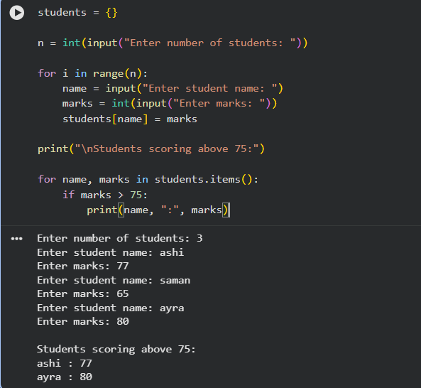

Q2-Write a program to sort a list in ascending and descending order.

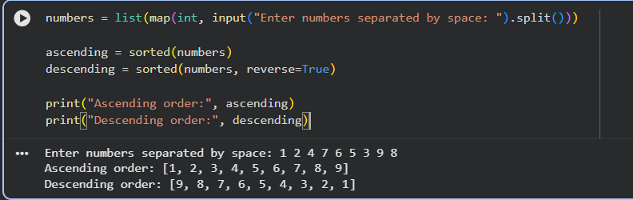

Q3-Write HTML code to generate the following output:

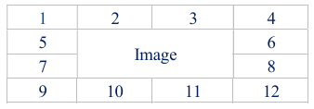

<!DOCTYPE html>
<html>
<head>
<title>Perfect Table Layout</title>

<style>
table {
border-collapse: collapse;
margin: 100px auto;
table-layout: fixed;
width: 480px;
}

tr {
height: 120px; /* Force equal row height */
}

td {
border: 1px solid black;
text-align: center;
vertical-align: middle;
font-size: 18px;
}

img {
width: 100%;
height: 100%;
object-fit: contain;
display: block;
}
</style>
</head>

<body>

<table>

<tr>
<td>1</td>
<td>2</td>
<td>3</td>
<td>4</td>
</tr>

<tr>
<td>5</td>
<td rowspan="2" colspan="2">
<img src="https://cdn-icons-png.flaticon.com/512/2721/2721297.png"
alt="Web Developer Coding">
</td>
<td>6</td>
</tr>

<tr>
<td>7</td>
<td>8</td>
</tr>

<tr>
<td>9</td>
<td>10</td>
<td>11</td>
<td>12</td>
</tr>

</table>

</body>
</html>

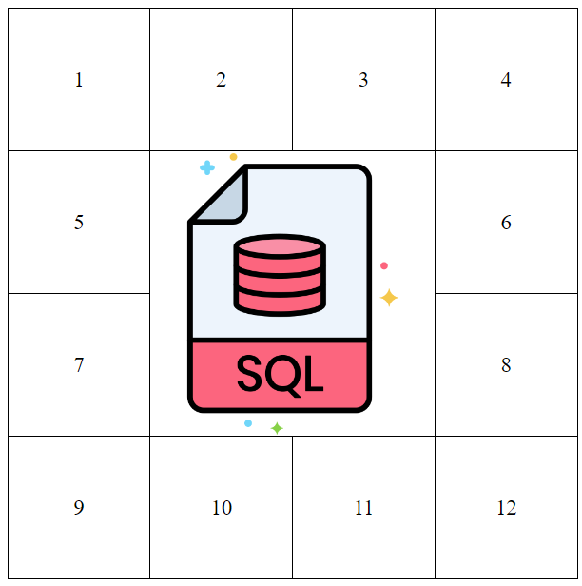

Q4-Write an HTML code to develop a Web page having two frames that divide the Web page into two equal rows and then divide the second row into two equal columns, then fill each frame with a different background color.

<!DOCTYPE html>
<html>
<head>
<title>Frame Layout</title>
<style>
body {
margin: 0;
}

/* First row */
.top {
height: 50vh;
background-color: lightblue;
display: flex;
justify-content: center;
align-items: center;
}

/* Second row container */
.bottom {
height: 50vh;
display: flex;
}

.left {
width: 50%;
background-color: lightgreen;
display: flex;
justify-content: center;
align-items: center;
}

.right {
width: 50%;
background-color: lightpink;
display: flex;
justify-content: center;
align-items: center;
}
</style>
</head>

<body>

<div class="top">
<h2>Top Frame</h2>
</div>

<div class="bottom">
<div class="left">
<h2>Bottom Left Frame</h2>
</div>

<div class="right">
<h2>Bottom Right Frame</h2>
</div>
</div>

</body>
</html>

